## horizontal line



Forgotten Youth

Sub title

Ryan Wildish

10524850

Git repository Link

YouTube Playthrough Link

# Overview

## Genre

Psychological Exploration Game

## Target Audience

I am targeting my game mainly at adults old enough to understand the repercussion of neglecting family members and what it can do to them (roughly 21+). This is also somewhat targeted towards teenagers as well, to get them to think before they act towards their parents.

## Game Backstory

You are the President of the United States, during another cold war with Russia, but this time China has joined the fray. The three countries continually tried to build bigger and better weapons and defence systems, mostly out of paranoia. Three days ago, the first bombs fell on American soil, with an immediate counter-attack against both China and Russia, the world looked doomed. Bombs had fallen in California, Texas, Ohio, Moscow, St. Petersburg, Beijing, Shanghai and Harbin. After just a few minutes of nuclear deployment a truce was quickly realised between the Countries, as they realised they would otherwise soon be annihilated. Plans were made to quickly establish Nuclear disarmament and to increase trust levels between the Countries.

After several terrifying days, you decide to go visit your parents’ house... or what’s left of it. You go down to a little-known town in Texas, and look upon the destruction with your own eyes. After donning an anti-radiation suit you hurry along to see what is left.

## Game Concept

The concept of the game is to get the player to enter a street scene expecting everything to be completely devastated (as a nuke has recently hit it). But when the player gets to their “parents” house they see a house still standing completely untarnished by the obvious chaos that has occurred around it. The player should feel bewildered and want to explore the house, which they will do. As the player interacts with certain objects there will be a, small comment on the memory of the object followed by a conversation between the player character and his parents (or either of them at least) from the past, when he was a child. The conversations will remind him of how mean and cruel he was to his parents, playing pranks, swearing at his parents, not doing as he was told, etc. After the conversation ends, the character will then comment on it, along the lines of how immature and mean he was, as a kid towards his parents.

## Game Flow

As the game will be very short, there won’t be much of a flow to the game. Instead, I aim to keep the player interested long enough to finish the game (max 5 minutes).

# Game Structure

## Game Progression

The player will progress from the start point to the only standing structure in the scene. From there, after the player enters the house, the player will progress through the interactions of certain objects (that will be glowing and present a UI command to interact) that will start the appropriate conversation with the given item. After all the interactions are finished the character will say that he thinks it’s time that he left, prompting the player to leave the house. After the player has left the house and gotten onto the sidewalk, the character will say “what was that?” (with background music stopping and no noise being played to indicate something has happened). As the player turns around to face the house, the player will find a house like the surrounding rubble remains. The character will be stunned and the game will end.

## Goals

The following goals will be added to the UI of the game to alert the player to their current objective.

Find your parents’ house

Enter the house

Look for family heirlooms - Find all the interactions

Exit the house and get back to Benson

Turn around……

## Rules

As the game is so limited in controls and functionality, there are no real rules apart from the limits of the controls (limited to move using WASD&UpLeftRightDownArrows and E to interact).

Past memories will be played after a specified object is interacted with.

Doors will open after being interacted with.

## Game Options

As of yet I am unsure of how to do certain options and so am limited to, at the moment, include mute sound and volume control.

## Game Conversations

There will be conversations throughout the game and this section of the GDD attempts to explain the timing of, and contents of these conversations.

1. Opening scene during a black screen. B = Benson P = President M = Mum D = Dad O = other

[Engine humming]

B “Mr President, we’re getting close to the destination… Hope your suits on properly, you don’t wanna’ go out there with a leak”

P “I think it’s okay, thank you Benson. I’ll be fine quit your worryin’”

B “Just remember not to take it off Mr President, or you’ll fry out there in the radiation. What is this place anyways?”

P “This… this is where I grew up, I… I thought I’d take one last look at the place…”

B “I’m not sure you’ll be able to recognise anything Mr President, that nuke woulda’ done a number on this place. I’m surprised anything’s still standin’ around here.”

P “Yeah, thanks for the sympathy Benson….”

B “I’m sorry Mr President, I wasn’t thinking straight. I’m sorry about your loss and all, just... everything’s a bit whack at the minute.”

P “It’s alright Benson”

B “Anyways were here now, I’m not sure how long I can sit here inside this suit Mr President, so please don’t take too long.”

P “I’ll be back before you know it”

[car door opens and closes]

2. Short dialogue as the president sees his parents’ house.

P “What the hell? How’s this the only house standing? Well I ‘spose it’s only right to have a good look around, at what’s left. “

3. Picture Frame Conversation

P “After all this time they’ve still got a picture up of me? Man, I remember how much of a pain I was getting this photo done.”

Memory starts.

M “Jack sit still and smile we’re just taking one picture darling.”

P “I don’t wanna, I just wanna play!”

D “Sit down Jack, now!”

P “NO, I DON’T WANNA”

M “Jack, you sit down right this instant”

D “Looks like a little someone’s going to bed without any dinner tonight…”

P “FINE, I’ll sit down for your stupid picture”

[photo sound]

Memory ends.

P “Man I was such a little tantrum thrower, over the most little things”

**4. Razor Conversation**

P “I remember when I played with one of these as a kid, I got such a yelling at”

Memory starts

D “JACK, PUT THAT DOWN NOW”

P “I’m just trying to be a grown-up dad.”

D “YOUR STILL A CHILD, THAT’S TOO DANGEROUS FOR YOU TO BE PLAYING AROUND WITH, PUT IT DOWN NOW!”

P “Why don’t you ever let me have fun dad? If I can’t use it neither can you…”

[Throws razor out of the window]

D “You think it’s funny throwing that out of the window do you? You can go straight to bed without any dinner.”

P “Bu..”

D “NOW, GET TO YOUR ROOM NOW!”

[loud stomping up the stairs]

D “AND DON’T COME OUT TILL YOU’VE LEARNT THE VALUE OF MONEY”

Memory ends.

P “It’s a wonder they ever put up with me, I don’t think I’d be able to cope.”

**5. Wallet conversation**

P “Dad’s old wallet, I remember sneaking a dollar or two out of here, the trouble I used to get into”

Memory starts.

D “Mary, have you been in my wallet”

M “No dear, I did the groceries on Tuesday remember?”

[short pause]

D “JAAAAAAAAAACK!"

[short pause]

P “What have I done now dad!?”

D “HOW DARE YOU!”

P “I didn’t take it!”

D “You didn’t take what? I don’t remember saying you took something!”

P “It wasn’t ME dad”

D “I don’t wanna hear it Jack. You get to your room now until I figure out what to do about this. I just don’t understand how you could steal from your own parents, I’m disappointed in you Jack.”

Memory ends.

P “How could I steal from the people who always fed me, clothed me. It wasn’t the best but it was better than most. [sigh]”

**6. Perfume conversation**

**[sprays perfume]**

P “Mum’s still got her fair share of perfumes then? I don’t understand why I thought I could get away with swiping her favourite one and selling it”

Memory starts.

M “Abe, have you seen my perfume.”

D “No honey, you sure you haven’t left it in the bathroom?”

M “No, it’s not there I don’t understand where it could have gone.”

[knocks on Jack’s door]

M “You haven’t seen my perfume have you Jack?”

P “No mum I haven’t seen it.”

M “Why’s your face all red Jack? Something to hide?”

P “It wasn’t ME mum. Get off my back already.”

M “Where’ve you hid it jack? What have you done with it, that was my favourite.”

P “NOTHING! I haven’t touched it, why’s it always my fault.”

[knocks from the front door]

O “Hey Mr Stanton, how ya doing, just thought I’d pop down and return this. My daughter bought it off your boy. She nabbed the money from my wallet, so I was hopin to get it back see.”

D “JAAAAAAAAAAAACK!”

Memory ends.

P “Why was I such an idiot? They never deserved this, they always worked so hard.”

**7.Vase Conversation**

P “How is this fixed? Didn’t I break this when I left them?”

Memory starts

M “What are you doin Jack?”

P “I’m leaving mom… and I’m not coming back.

M “No you can’t do this dear how are you going to survive out there on your own”

P “I’ll figure it out, I just can’t stand you two breathing down my neck all the time, just thinking I’ve done everything wrong, ALL THE TIME.”

M “No, it’s okay Jack you don’t have to go, ABE, Abe, stop him, he can’t leave.”

D “What has he done this time?”

M “No Abe, he’s leaving, he’s packing his bags right now.”

D “Good, it’s about time he saw what the real world is like. He’ll be locked up before you know it.”

M “Don’t say tha…”

P “Don’t talk about me like I’m not even here. You two just don’t understand me, I’m leaving and I’m never coming back!”

[pottery smashing against floor]

[sobs from the mum]

D “Don’t think you can just waltz back in here when you get tired of being a grown up. You hear me!.. Good riddance to him” [gets quitter as Jack walks further away].

Memory ends.

P “I haven’t seen them since… it’s been a long 27 years… I’m back mum… dad… I’m home…”

[two honks from the car]

B “COME OOOON, QUIT YOUR STARIN, I NEEDA PISS AND I’TS NOT LIKE I CAN GO IN THIS SUIT”

P “Aww crap, I better go then, this is getting me down too much anyway. If only I had a second chance to make it up to them…”

**8.Exiting house**

As the player walks out of the house the character will exclaim about hearing a noise.

P “What was that, was that behind me?”

[prompts player to look behind them: psychological sound]

[The house is now just a pile of rubble like the other houses]

P “What the ffff”

[cuts to credits screen]

**9.After Credits Music becomes**

**[Engine humming]**

B “What the hell were you starin at fer so long then Mr President.”

P “I… I thought I was in the house…”

B “What? What the hell are you on about, there’s just a big ol’ pile of house left there now. You were just stood there! Staring at the rubble, the whole time.”

P “WHAT?”

[game ends – return to main menu]

# Mechanics

## Interaction

Within the environment there will be specific objects that the player can interact with.

These will include doors, a picture frame, a vase, a perfume, a razor and a wallet.

Doors will open and close when interacted with.

The other items will invoke a comment from the character and start a past conversation between the character and his parents. After the conversation the character will comment on it.

## Movement

The character will have very simple movement controls that will come from the Unity first person controller, which will include, WASD to walk and the mouse to look around, jumping will be disabled.

## Objects

The environment will have plenty of objects in and is planned to be very detailed. The environment is supposed to simulate a real world one, to allow the character to be more drawn in.

Most of the objects in the environment will be just for show and non-interactable but some will be interactable (see interactions).

## Actions

Actions will only include WASD movement along with the E button to interact with certain objects.

## Combat

The game will not feature any combat.

## A.I

There will be no need to add any AI mechanics to the game, as it is very linear and short, with no enemies.

## Space

The space in the game, should feel like a real world street set in America.

# Characters

## Character 1

Name – Jack Stanton

Appearance – Tall, dark hair, finely groomed, wearing a suit.

Backstory – Jack always hated his childhood, during and after it. Trying to free himself from his parents grip, Jack eventually became part of the US Congress and then the President of the USA. After Jack left home at 17 years old, he never looked back or ever contacted his family.

Stereotypes – Smart Ass

## Character 2

Name – Mary Stanton

Appearance – Medium height, glasses, brunette

Backstory – During a difficult time for the town she resided in as well as her family, Mary tried to work as hard as she could to keep costs to a minimum around the house and get all the house chores done. As she was never able to get a job she felt obliged to do as much as she could for her husband to lift some stress off his shoulders. Despite this the two often bickered due to money issues amongst other things.

Stereotypes – Motherly

## Character 3

Name – Abe Stanton

Appearance – Tall, dark hair

Backstory – Abe worked in a small factory as a regular worker, bringing in a minimal income for his family. Abe never liked this and always strived to get promoted or otherwise find a better job, but was never able to during Jack’s adolescence. Abe always blamed himself for this, and started to grow away from his wife and child. Some nights Abe would let out all his stress to his wife, by shouting at her, causing arguments etc. this made him feel worse after he had calmed down.

Stereotypes – Strict Father

# Menu System

## Menu Screens

Main Menu Diagram

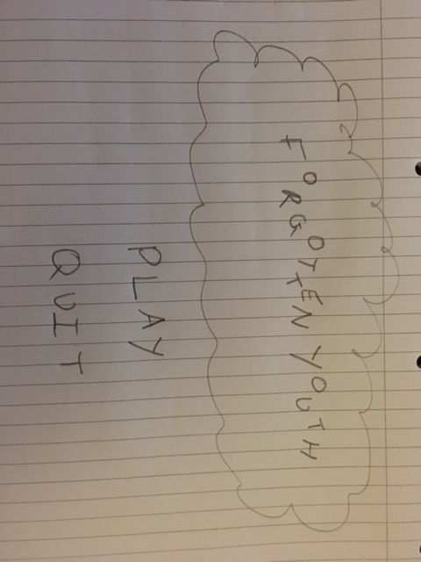

Main Menu Description

The main menu will feature limited elements with just two buttons to either play or quit. The name of the game “Forgotten Youth” will be above these two buttons (vertically) with a weird and almost random scattered effect to the letters, but just enough so that the title is still readable. There will also be some cloud particle effects behind this title to give a more dreamlike and hopeful impression. The background of this main menu will be a sky blue to also help portray this.

Game Scene Description

There will be no UI for the player in this game, so there is no need to produce an appropriate sketch of this. The only UI elements will include a pop up of “Press E to interact” when in range and looking at an interactable object (except doors).

# Level Design

## Key

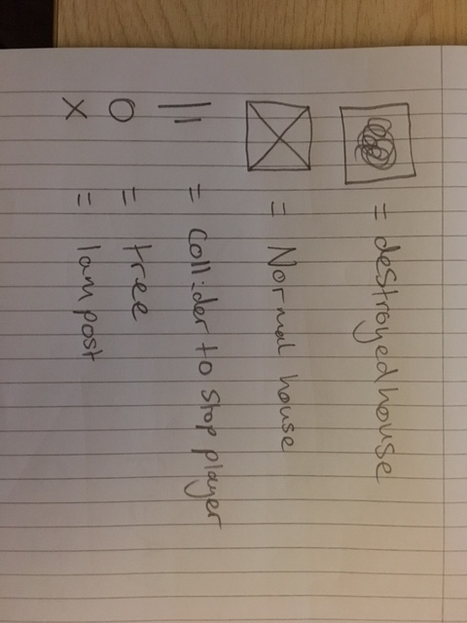

## Level Diagrams

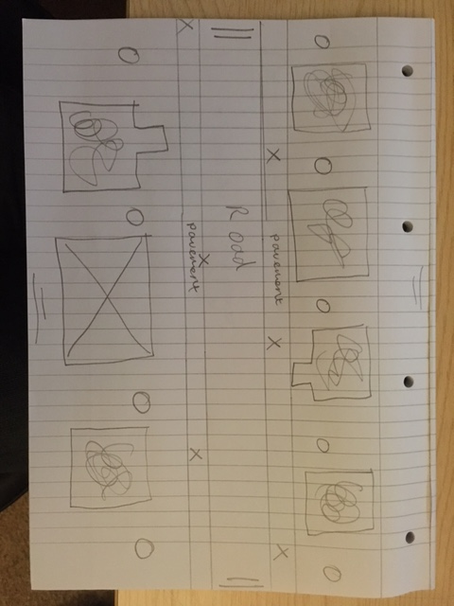

# Artistic Direction

## Mood Boards

Game World

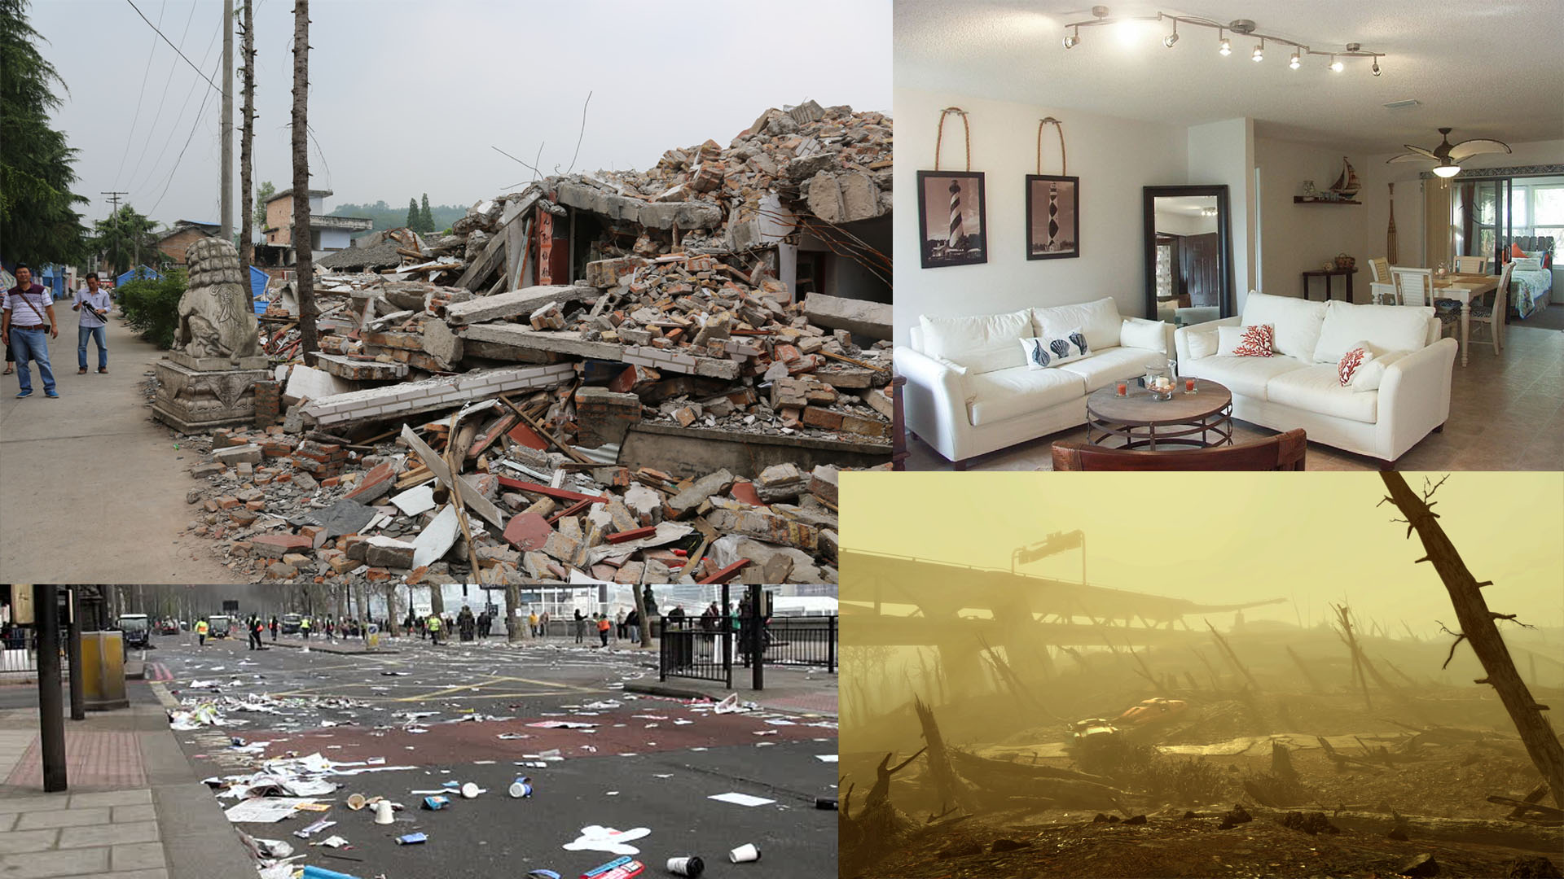

This moodboard shows some very key points that I wish to touch on in this project should time allow me. I want the collapsed buildings to look broken down to almost every brick as if an earthquake has hit (or a nuke in this case).

Another picture (top Right) shows a pristine looking house, this will be the house the player goes into and looks around. It is important that this house looks pristine and clean as it is from the character’s memory and therefore should not have any marks/dirt, as this makes the house seem more memory/angelic like.

In the bottom left we can see an immense amount of litter on the floor, the outside of my scene should have more rubbish than this although it should be charred and disfigured.

In the bottom right we can see the devastation left by nukes (according to BethSoft) and I would like my outside vegetation to look similar to this.

## Similar Games

I could not think of any game that is similar to this game.

Some similar themes however may include;

Fallout series

Wasteland

Metro series

Mad Max

# Technical

## Target Hardware – Windows

I am targeting this game for the PC platform and have thought out the control scheme appropriately (see 8.3 In game controls).

## Development Software – Unity, 3DS Max, Photoshop

Unity

3DS Max

Photoshop

## In Game Controls

WASD – Character movement

Mouse Movement – Move character view

E – Interact

Escape – Pause (brings up pause menu)

## Original Idea

My idea will be an idyllic town, that feels happy and upbeat, the sun is shining, the birds are singing

The player will know that something bad is going to happen, but no one else you speak to knows about it and you don't want to freak them out.

The player will play as the president (USA), and visiting his home before the event happens, saying goodbye to his parents before he makes his way to the shelter.

There will be several interactions between the president and the residents in the town before the nuke hits, and then when the president explores the town in its aftermath (in a radiation suit) talks to himself about some memories of the town.

I'm not sure yet how I will allow for the transition of the nuke to take place and how the president actually survives.

After some interactions there will be a nuke that hits, where a flash will transition the scene to the aftermath, destroyed buildings, trees, etc.

The player will then be able to explore the scene a little bit before it ends.

## Feedback

During some conversation/feedback, some questions were raised,

realism in models: will be as realistic as I can make them, will be hard to model humans :( might have to simplify them

Key design decisions: I will be focusing on the asset creation rather than gameplay which will essentially be a walking simulator.

Changed the scene to only be post-nuke, and the character will recount regrets and other memories throughout the scene.

These memories and regrets will be heard when entering buildings that still look as if they hadn't been hit by a nuke, but after coming out of the house and turning around the house is gone and there is only rubble, where you were just stood.

From this feedback I have changed the original idea, and now have used this document to fully detail the plan.

## Minimum Deliverables

○ 4 individual buildings ○ 1 piece of foliage ○ 1 decal ○ 1 Interaction ○ Show good choice of materials throughout ○ Show good choice of sound throughout ○ Full menu system ○ Identifiable theme/genre ○ Appropriate Sound Design treatment including: ○ 4 original spot effects ○ 4 original ambient sounds ○ 4 Foley effects ○ Inclusion of voice recording

## Deliverables

4 individual buildings have been done and are named – HousesCollapsed | CollapsedHouse2 | CollapsedHouse4| HouseWithoutSkirtingv2

1 Piece of Foliage – FernPlantPot | Tree3

1 decal – mud on road, ran out of time to apply to other objects

1 interaction – I have 6 different interactions which include;

Interacting with doors

Interacting with the Photo

Interacting with the Razor

Interacting with the Wallet

Interacting with the Perfume

Interacting with the Vase

Full Menu System – Menu system working fully! Created UI elements for when player presses Escape. The game will pause, whilst also locking the mouseLook script and pausing any dialogue taking place. The ambient tracks will still play during the pause menu however. When in the pause menu the player is able to wait for as long as they would like before returning (provided their computer settings don’t intervene) and then press Continue/Escape key to continue playing, Quit to Main Menu to quit the level and return to the main menu, or Quit to Desktop to quit the game entirely and go back to the desktop.

4 Spot Effects and 4 Foley Effects – Car Door | House Door |

4 Ambient sounds – Wind | Guitar for StartMenu | Guitar for MainLevel (Yes, they are different, but they are supposed to be similar) | Guitar for Credits | Car Humming

Voice Recording – In the game I have 9 pieces of recorded conversations that add to the story and tell the player what is happening and what they need to know.

Design Documentation – Check

Raw art assets are packaged in zip, downloaded to server

List references are also packaged in zip, downloaded to server

Evaluation and Analysis document also packaged

Prototyping – After coming up with the idea of making the house disappear and a collapsed house takes its place, I was worried about how I would make this to happen. I created a very small prototype that makes a box move and a sphere to take its place. I then repeated this process with a sphere as a child of the box so the box and sphere would move away while a different sphere would take the place of the box and sphere. As this worked well I knew I would be able to implement this into the game.